**Butterworth Filters**

**Introduction**

In the field of signal processing, a filter is a device or process that, completely or partially, suppresses unwanted components or features from a signal. This usually means removing some frequencies to suppress interfering signals and to reduce background noise.

The Butterworth filter is a type of signal processing filter designed to have a [frequency response](https://en.wikipedia.org/wiki/Frequency_response) that is as flat as possible in the [passband](https://en.wikipedia.org/wiki/Passband). It is also referred to as a maximally flat magnitude filter. Though the applications of a filter in signal processing are self-explanatory, here are some specific application of Butterworth filters:

The applications of a Butterworth filter are listed below:

* Because of the maximal flat frequency response in the passband, it is used as an anti-aliasing filter in data converter applications.
* The Butterworth filter is used in the audio processing application. An efficient audio noise reduction tool can be developed using a Butterworth filter.
* It is also used in various communication and control systems.
* It is used in radar to design the display of radar target tracking.
* It is used for motion analysis.

Further several filters can be modelled in Butterworth filter models using approximations are analyzed easily.

**Characteristics**

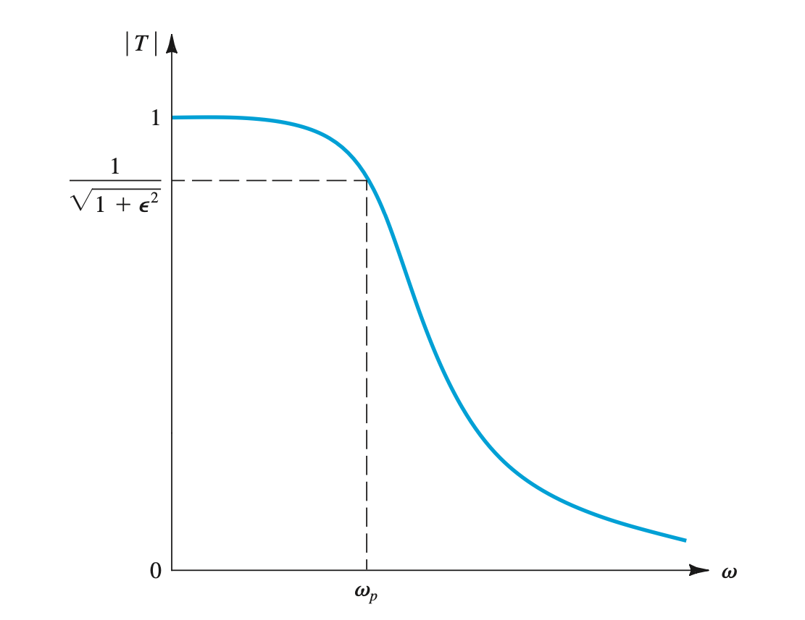

Figure 1

Figure 1 shows a sketch of the magnitude response of a Butterworth filter. This filter exhibits a monotonically decreasing transmission with all the transmission zeros at ω = ∞, making it an all-pole filter. The magnitude function for an *N*th-order Butterworth filter with a passband edge ω*c* is given by :

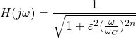

n = order of the filter,  
ω = operating frequency (passband frequency) of circuit  
ωC  or $ω_{p}$ = Cut-off frequency

ε determines the maximum variation in passband transmission

The below equation is used to find the value of ε.

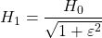

Where,  
H1 = minimum passband gain =1 for calculations.  
H0 = maximum passband gain

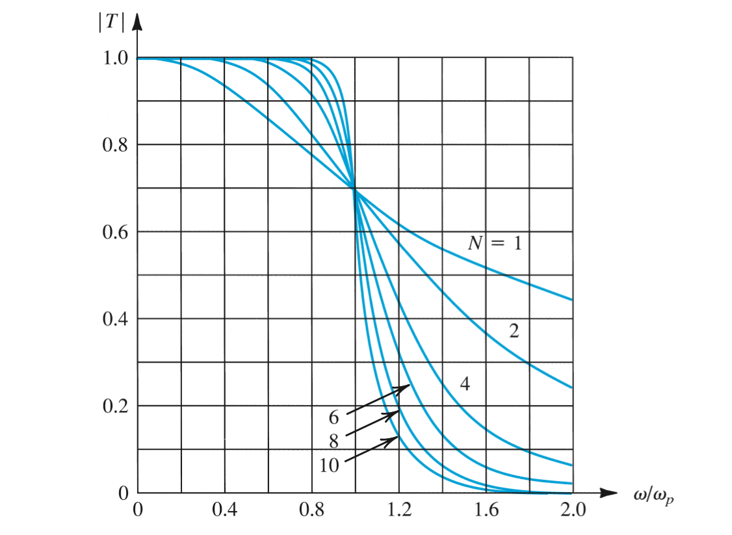

Figure 2 :Magnitude response for Butterworth filters of various order with ε = 1. Note that as the order increases, the response approaches the ideal brick-wall type of transmission.

Observe that in the Butterworth response the maximum deviation in passband transmission (from the ideal value of unity) occurs at the passband edge only.

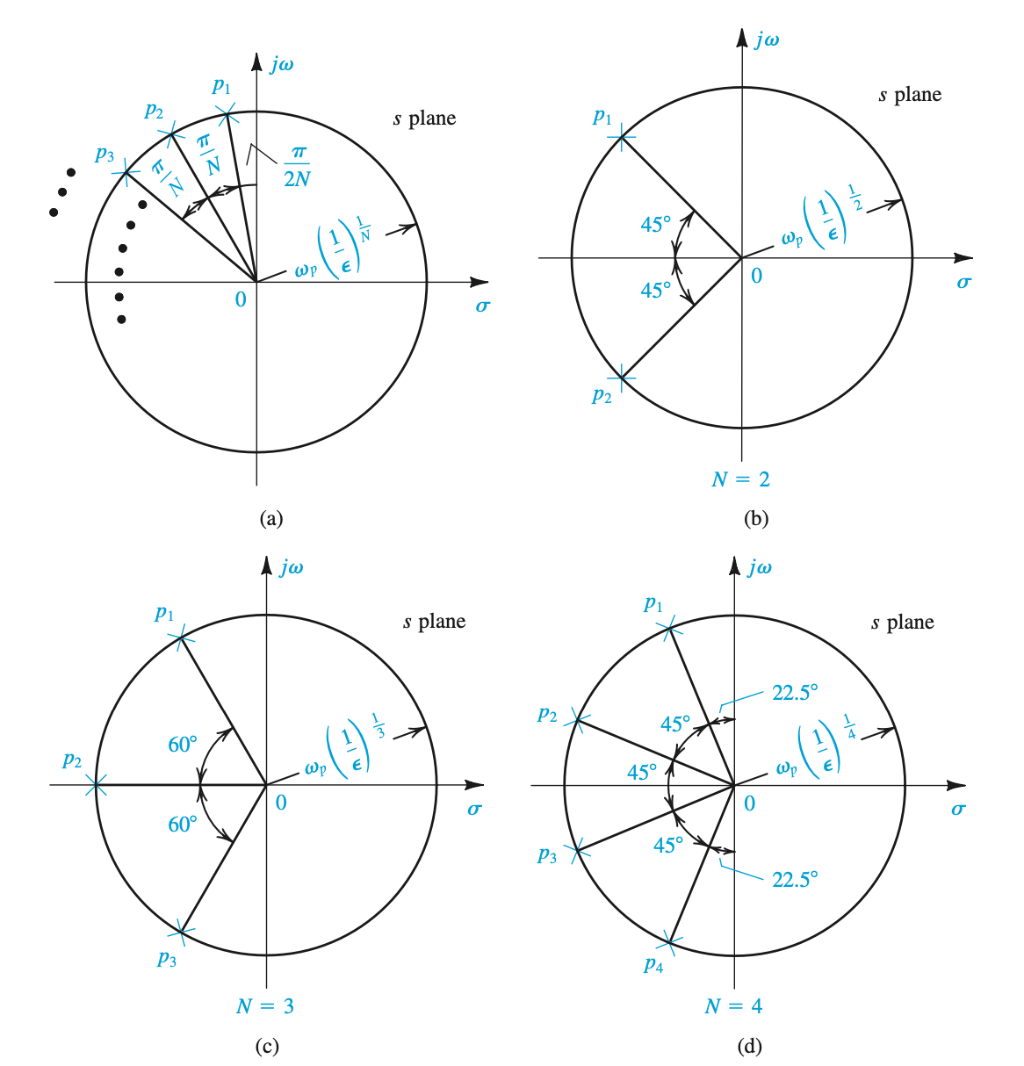

Figure 3: Graphical construction for determining the poles of a Butterworth filter of order *N*. All the poles lie in the left half of the *s* plane on a circle of radius ω0 = ωc (1/ε)1/*N* , where ε is the passband deviation parameter. a) General Case b) N=2 c) N=3 d) N=4.

Observe that first 2*N* – 1 derivative of |*T* | relative to ω are zero at ω = 0. This property makes the Butterworth response very flat near ω = 0 and results in the name maximally flatresponse. The degree of passband flatness increases as the order *N* is increased, as can be seen from Fig. 2. This figure indicates also that, as should be expected, as the order *N* is increased, the filter response approaches the ideal brick-wall type of response.

At the edge of the stopband, ω = ω*s*, the attenuation of the Butterworth filter can be

obtained by substituting ω = ω*s* in the characteristic equation. The result is given by

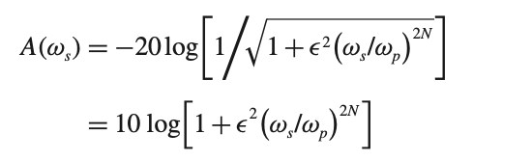

This equation can be used to determine the filter order required, which is the lowest integer value of *N* that yields *A*(ω*s*) ≥ *A*min.

The natural modes of an *N*th-order Butterworth filter can be determined from the graphical construction shown in Fig. 3. Observe that the natural modes lie on a circle of radius $ω_{p}{(\frac{1}{ϵ})}^{1/N}$ are spaced by equal angles of π/*N*, with the first mode at an angle π/2*N* from the +*j*ω axis. Since the natural modes all have equal radial distance from the origin, they all have the same frequency ω0 = $ω_{p}{(\frac{1}{ϵ})}^{1/N}$. See Fig. 3 (b), (c), and (d) for the natural modes of Butterworth filters of order *N* = 2,3, and 4, respectively. Once the *N* natural modes *p*1, *p*2,...,*pN* have been found, the transfer function can be written as

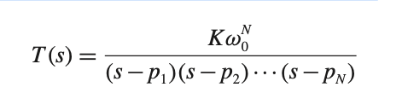

where *K* is a constant equal to the required dc gain of the filter.

**Sallen Key Low Pass Filter:**

A practical example of a butterworth 2nd order filter is the Sallen-Key low pass filter.

This filter can give us all types of dynamic responses viz. overdamped, underdamped and critically damped. The Sallen and Key filter is an active filter design based around a single non-inverting operational amplifier and two resistors, thus creating a voltage-controlled voltage-source (VCVS) design with filter characteristics of, high input impedance, low output impedance and good stability, and as such allows individual Sallen-key filter sections to be cascaded together to produce much higher order filters.

The detailed analysis of the filter is given below:

The parameter $ξ$ determines the type of response. 3 type of unit step response can be obtained from the topology. These were plotted in matlab:

Matlab Code:

clc;clear all;

wn=3;

num=9;

den1=[1 7.2 9];

den2=[1 30 9];

den3=[1 0.6 9];

den4=[1 4.2 9];

den5=[1 6 9];

step(num,den1);

hold on

step(num,den2);

step(num,den3);

step(num,den4);

step(num,den5);

grid on

xlabel('t');

ylabel('y(t)');

title("1ST ORDER UNIT STEP RESPONSE");

legend('\xi=1.2','\xi=5','\xi=0.1','\xi=0.7','\xi=1',Location='BEST');



Observe that for $ξ>1 we get overdamped response, ξ1 critically damped response$ and for $ξ<1 we get underdamped oscillatory response.$

Here’s the frequency response

clear all;

clc;

wn=3;

w=logspace(-1,2,100);

num=9;

den1=81./sqrt(((9-w.^2).^2)+0.64*9*w.*w);

den2=81./sqrt(((9-w.^2).^2)+1.44*9*w.*w);

den3=81./sqrt(((9-w.^2).^2)+2.56*9*w.*w);

den4=81./sqrt(((9-w.^2).^2)+4*9*w.*w);

den5=81./sqrt(((9-w.^2).^2)+16*9*w.*w);

grid on

semilogx(w,20*log10(den1));

hold on

semilogx(w,20*log10(den2));

semilogx(w,20*log10(den3));

semilogx(w,20*log10(den4));

semilogx(w,20*log10(den5));

legend({'\xi=0.4','\xi=0.6','\xi=0.8','\xi=1','\xi=2'},Location='best');

xlabel('f');

ylabel('Gain(dB)');

title('FREQUENCY RESPONSE OF 2ND ORDER INSTRUMENTS');

grid on

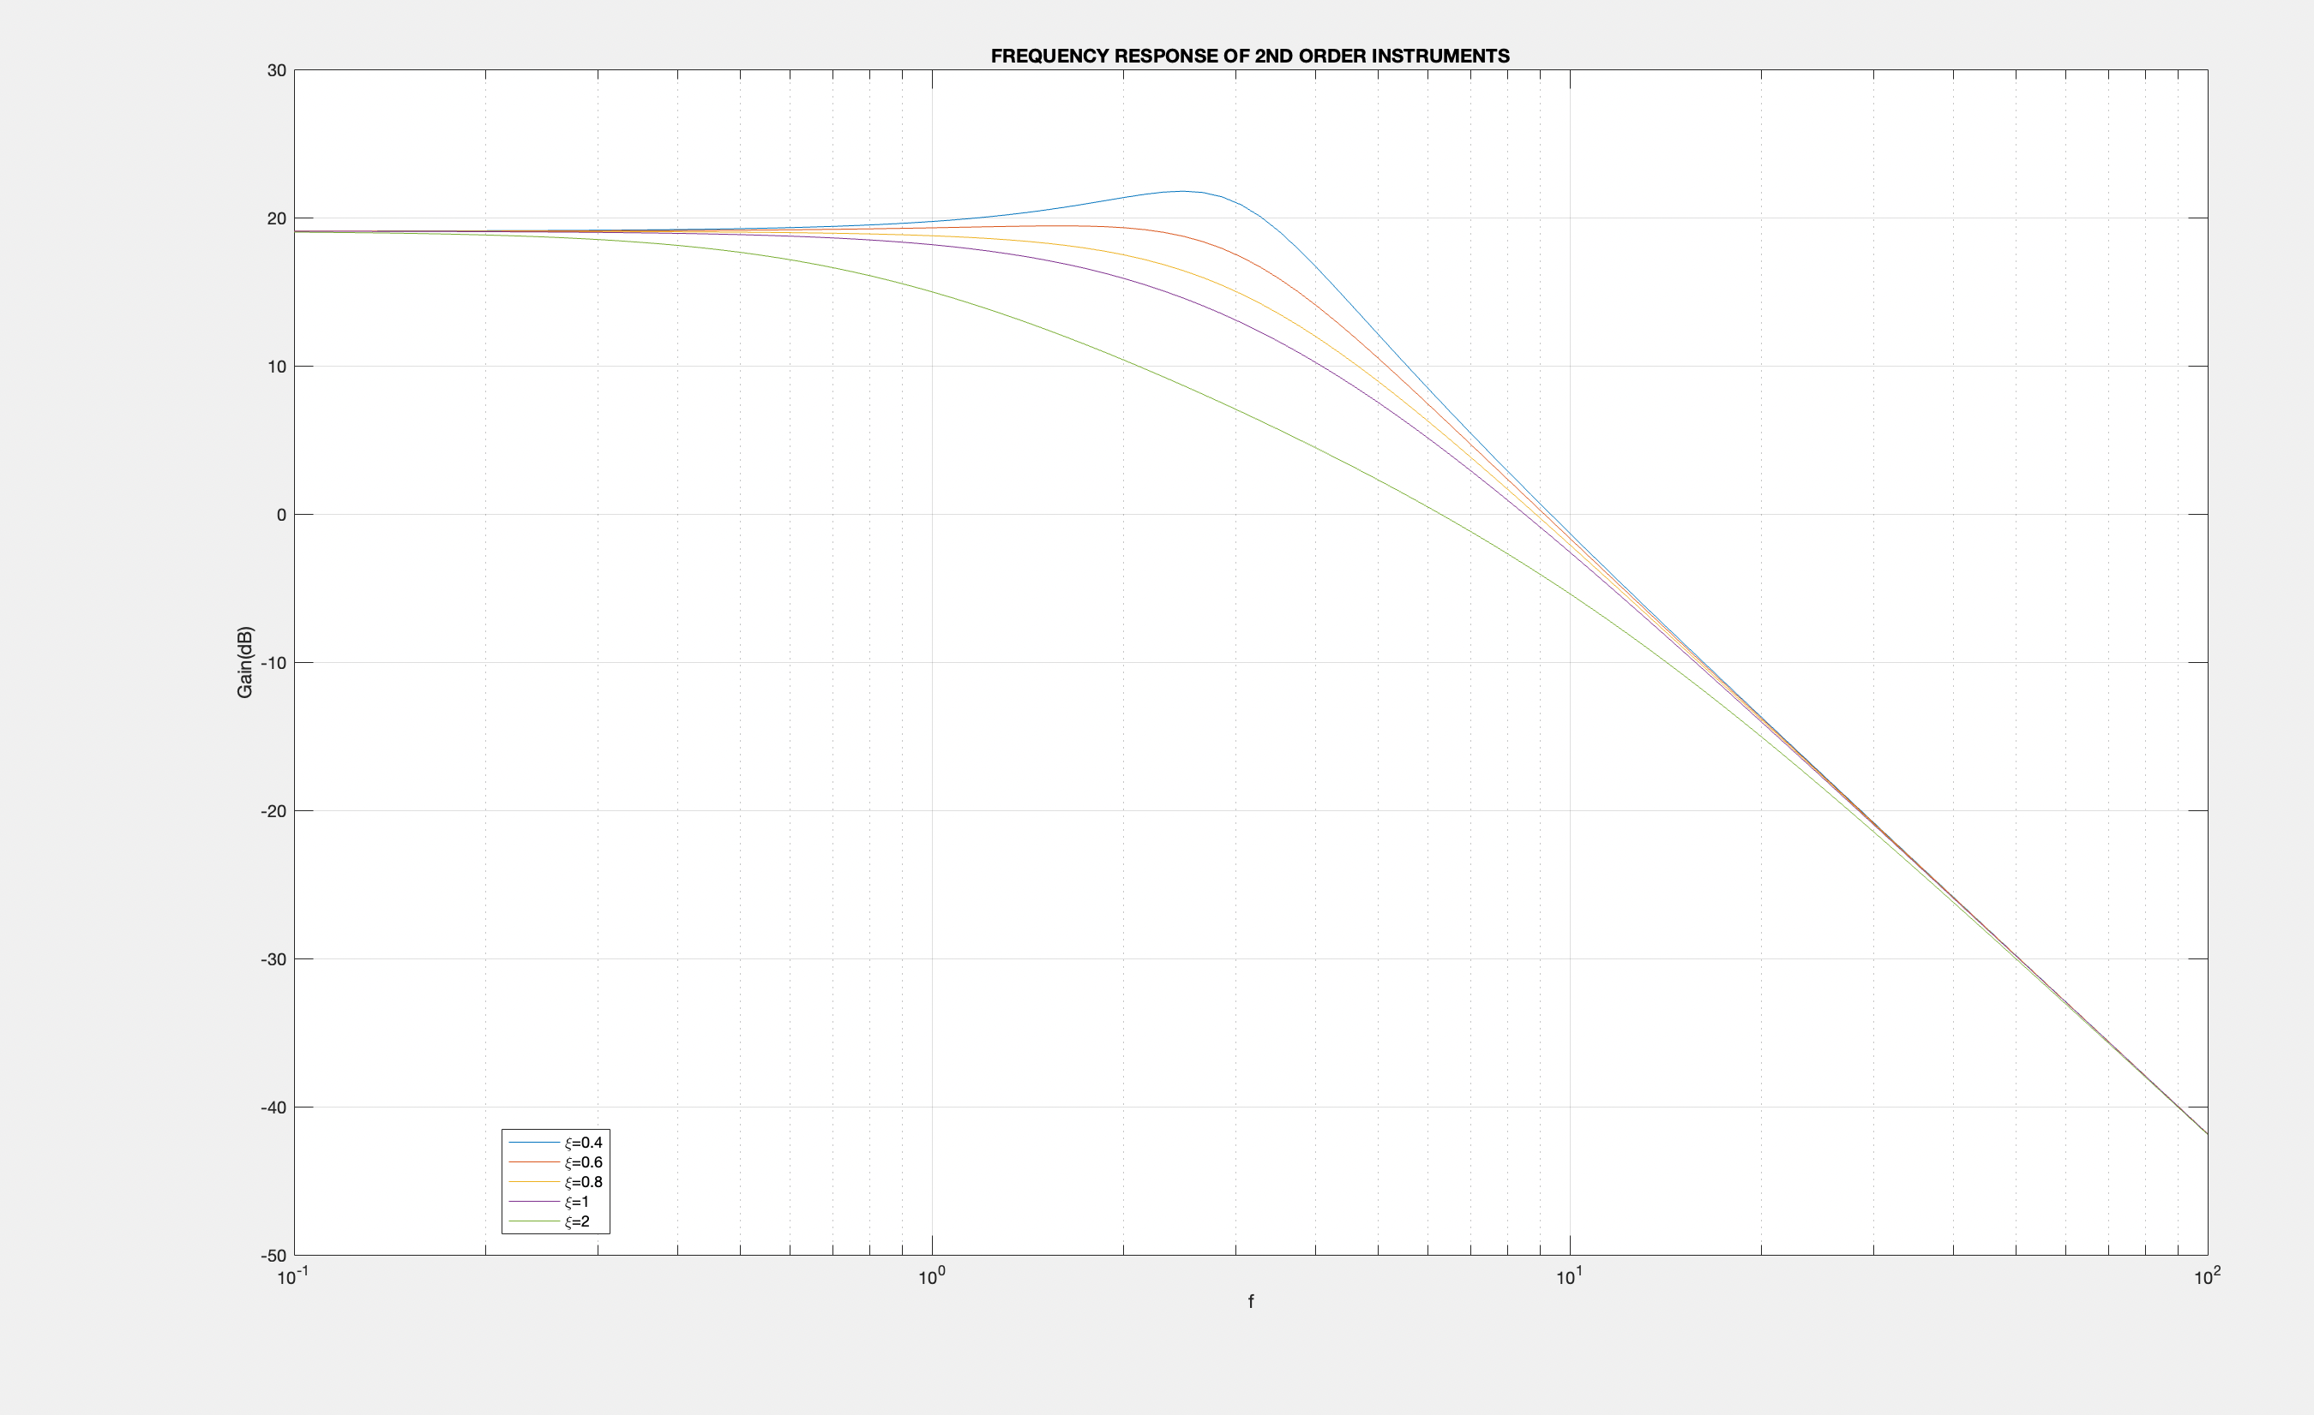

Here are simulation results from ltspice:

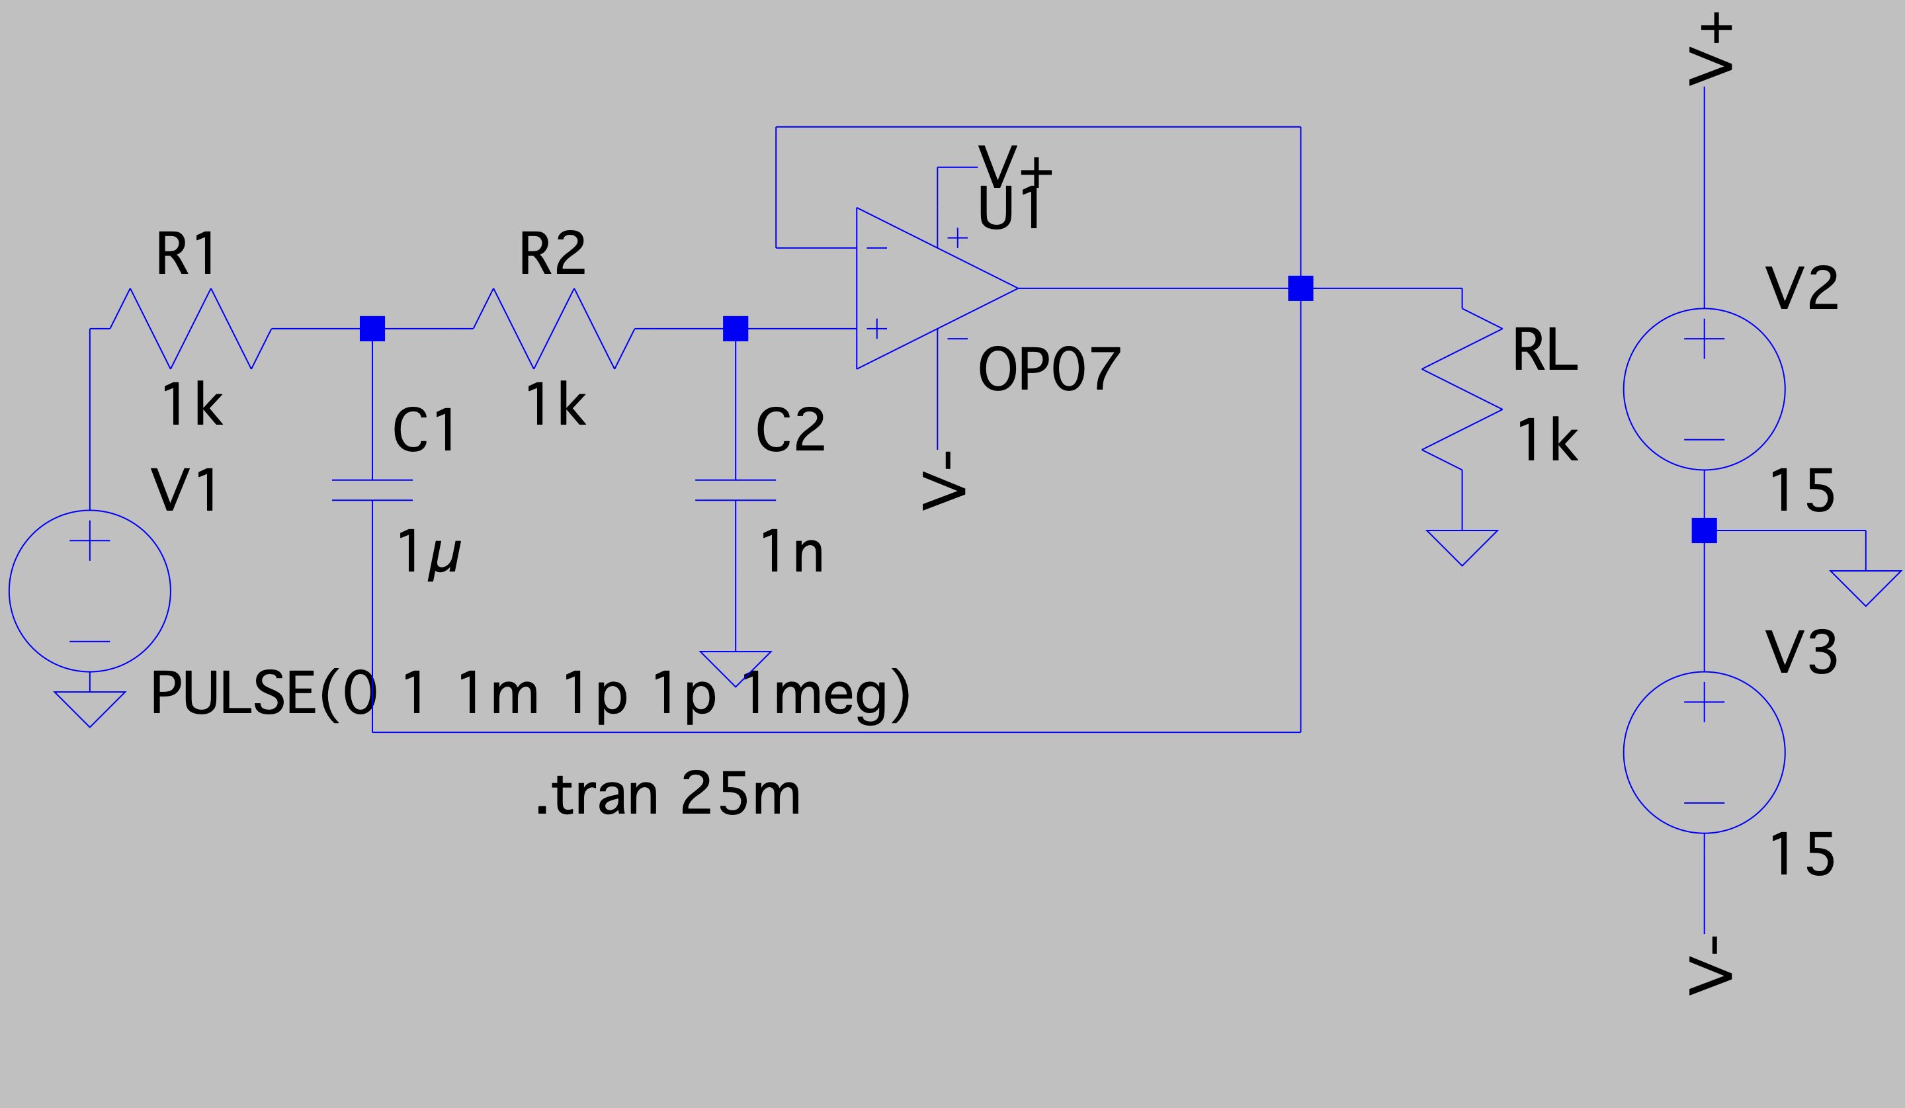

The plots are the corresponding frequency response and unit step response:

Underdamped with $ξ=0.032$.

R1=1k $Ω$, R2=1k $Ω$, C1=1 $μF$, C2=1nF.

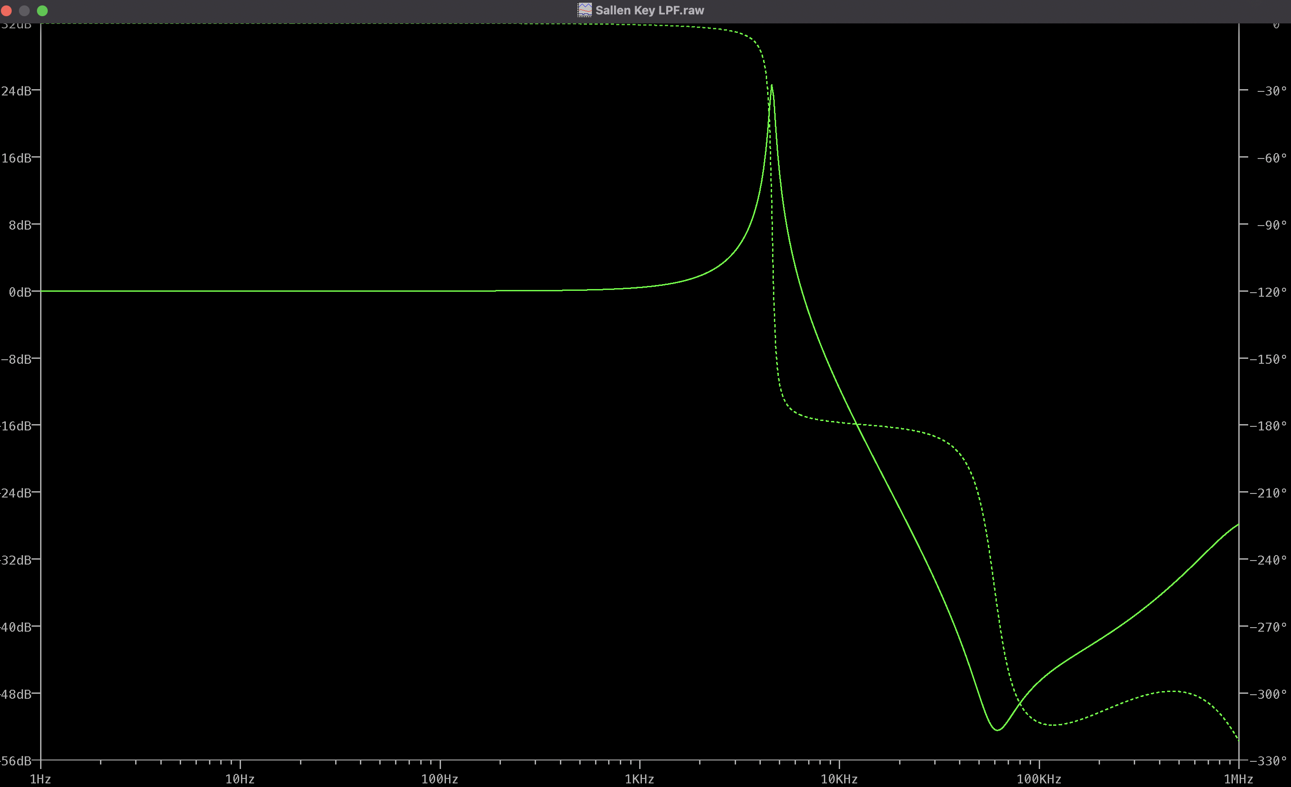

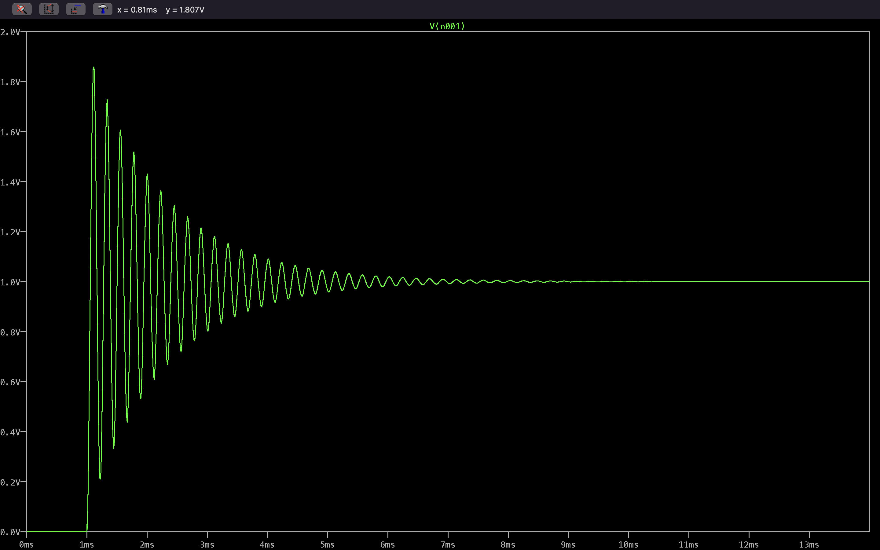

R1=1k $Ω$, R2=1k $Ω$, C1=2200p $F$, C2=1nF.

Underdamped with $ξ=0.674.$

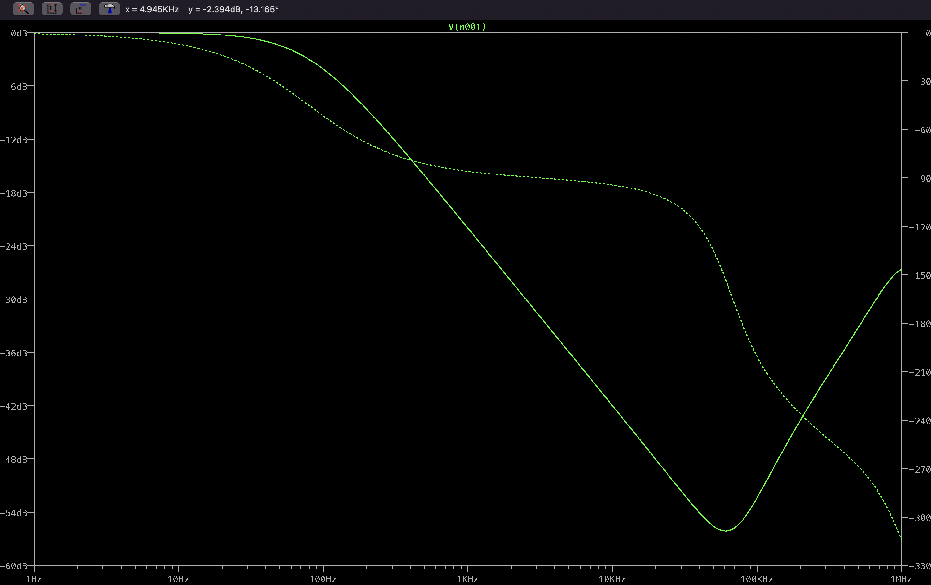

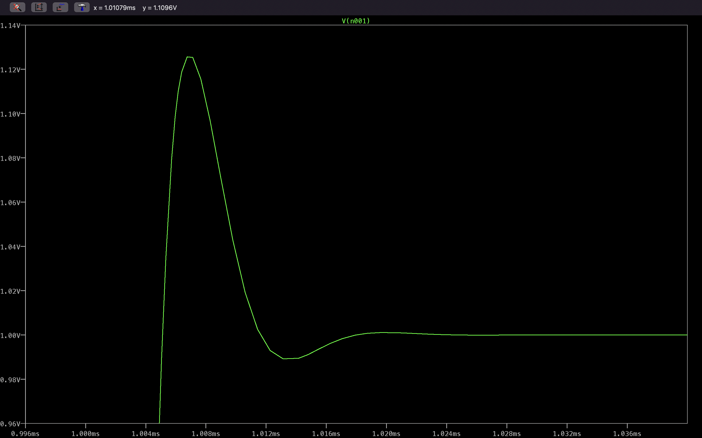

R1=1k $Ω$, R2=1k $Ω$, C1=1 $600pF$, C2=1nF.

Underdamped with $ξ=0.79$

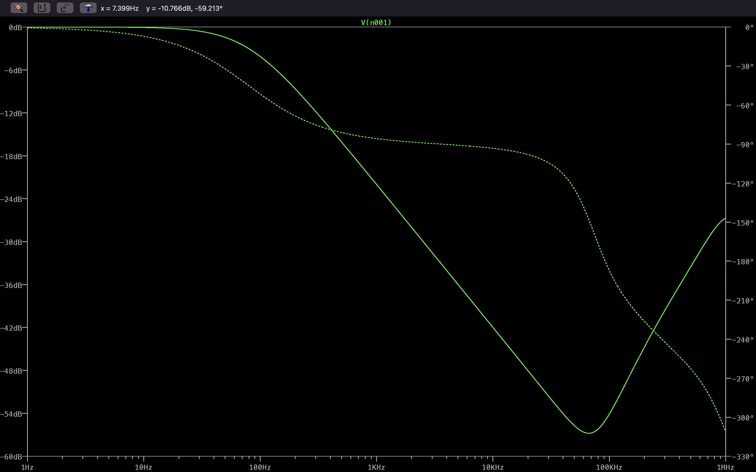

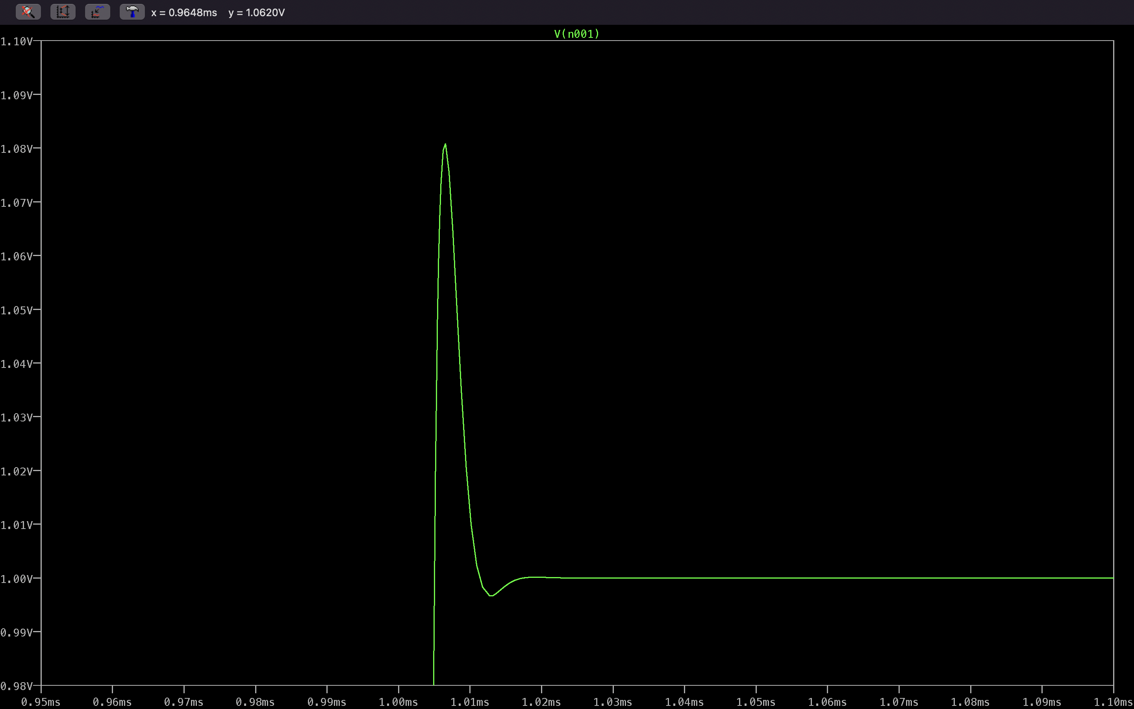

R1=1k $Ω$, R2=1k $Ω$, C1=1 $00nF$, C2=100nF.

Critically Damped

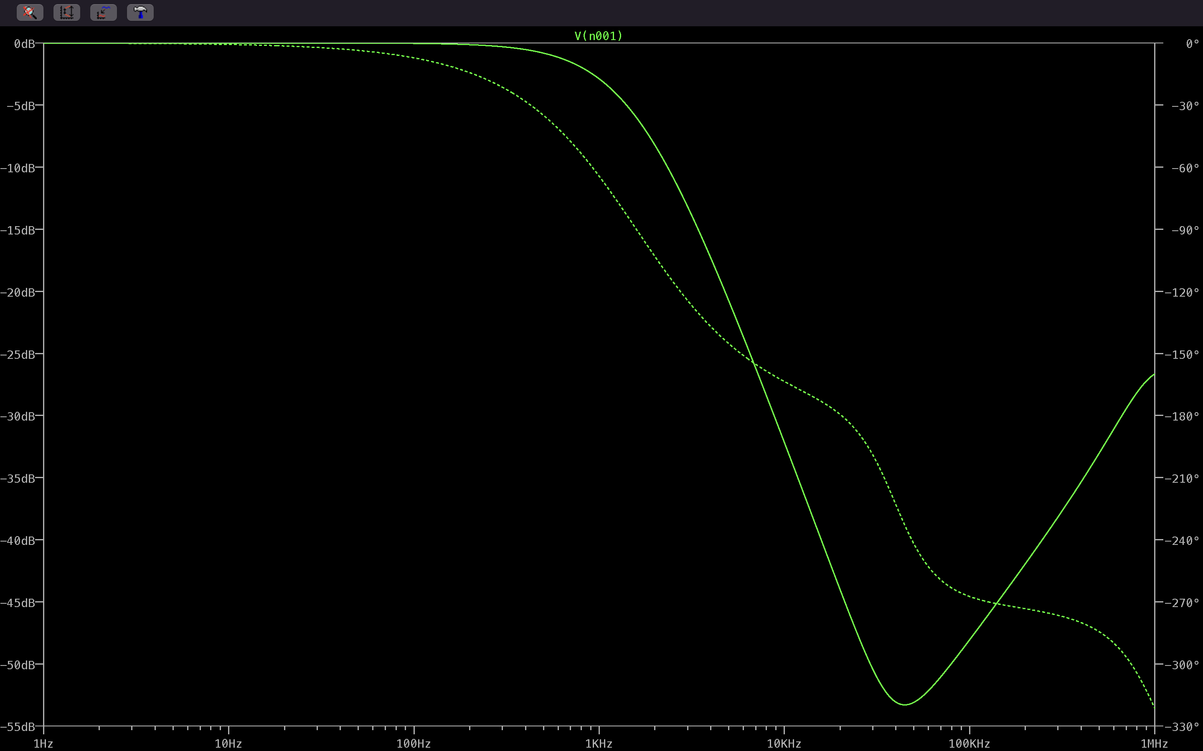

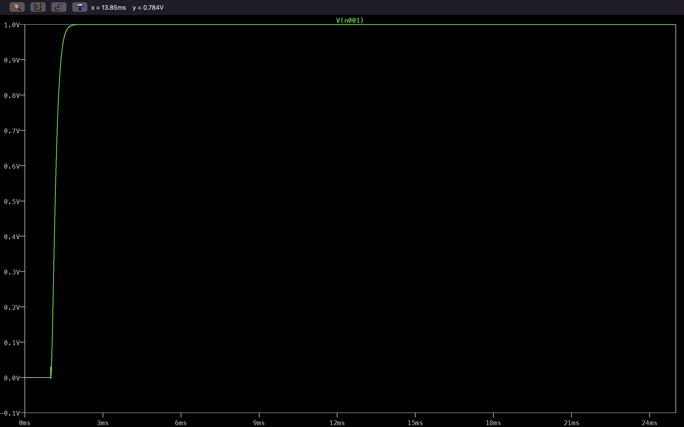

R1=1k $Ω$, R2=1k $Ω$, C1=1 $00nF$, C2=1 $μ$ F.

Overdamped with $ξ=3.1622$

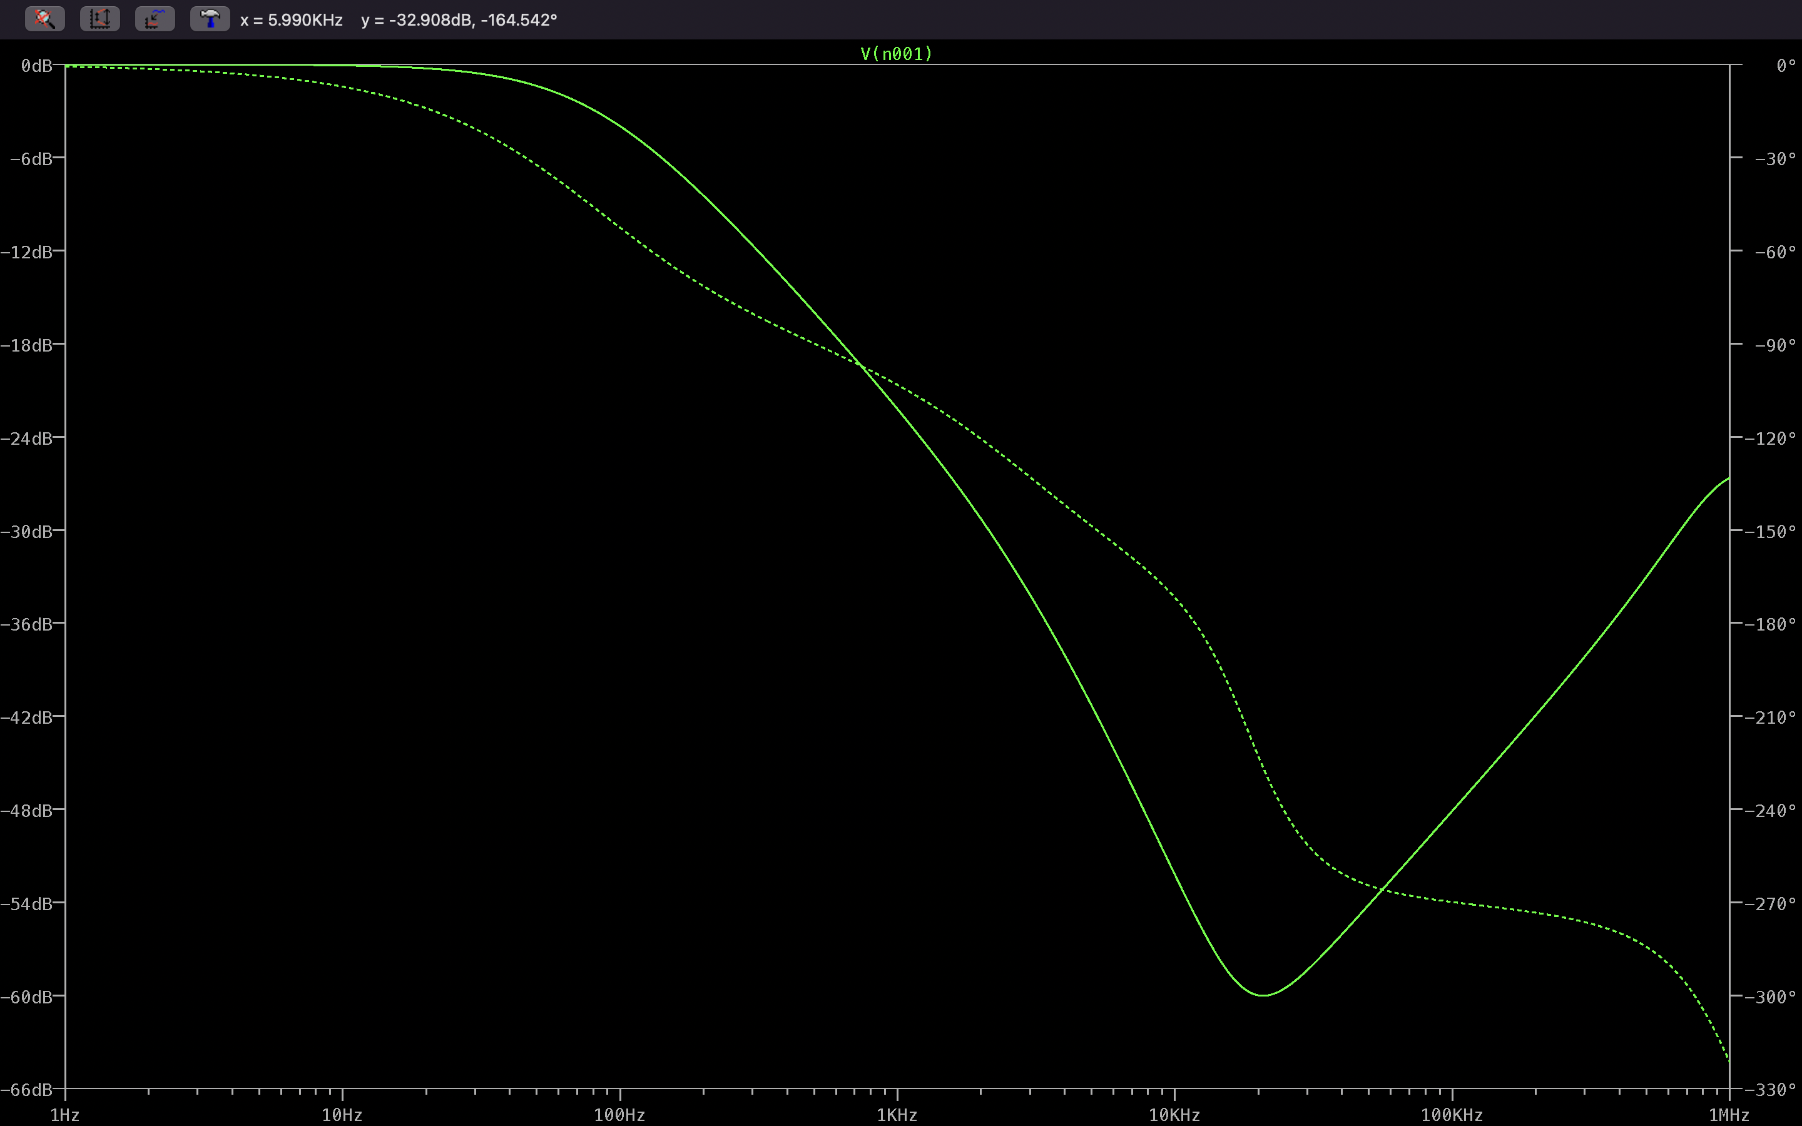

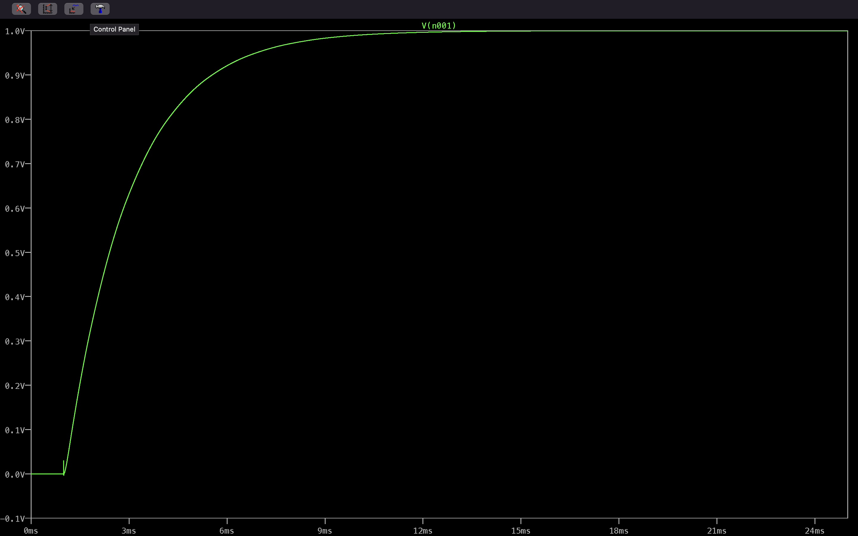

**Conclusion:**

We examined the results of a Butterworth filter and analyzed a practical and useful example of a Sallen Key LPF. Many other practical filters can be modelled like this into Butterworth filters and can be analyzed similarly. Along with its usefulness and advantages we have its own disadvantages also. One main disadvantage of the Butterworth filter is that it achieves this pass band flatness at the expense of a wide transition band as the filter changes from the pass band to the stop band. It also has poor phase characteristics as well. These can be overcome by choosing other type of filters like Chebyshev, Elliptic etc.

**References:**

1. <https://www.electronics-tutorials.ws/filter/filter_8.html>
2. <https://www.electronics-tutorials.ws/filter/sallen-key-filter.html>
3. <https://en.wikipedia.org/wiki/Butterworth_filter>
4. Microelectronic Circuits by Sedra Smith
5. <https://en.wikipedia.org/wiki/Filter_(signal_processing)>
6. Signal Processing and IC by Baher
7. Digital signal processing: system analysis and design book by eduardo antônio barros da silva, paulo s. r. diniz, and sergio l. netto

By Nithin M

SC20B101